SǪL and Databases:

Project Report



By: Aaditya Kumar Ravi (AIML ONLINE SEPTEMBER 23 A)

Business Overview

Total Revenue
32.1 M
Total Orders
1000
Total Customers
994
Avg Rating
3.1

Last Ǫtr Revenue
5.5 M
Last Ǫtr Orders
199
Avg Days to Ship
98
% Good Feedback
44%

Customer Metrics

Distribution of Customers across States

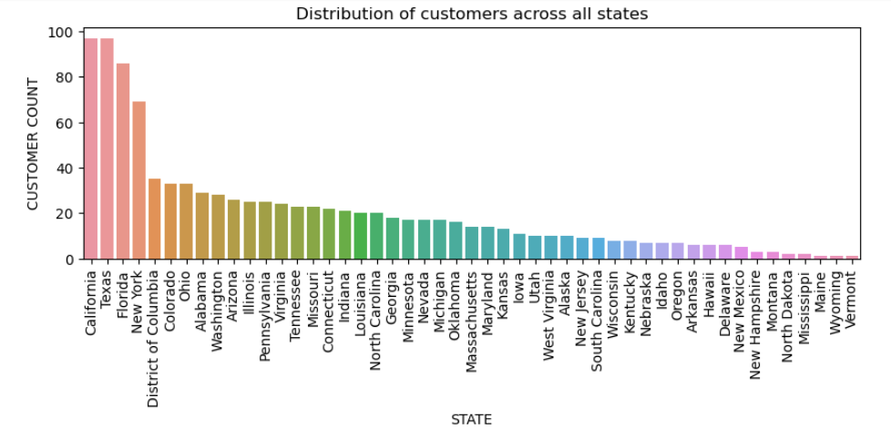

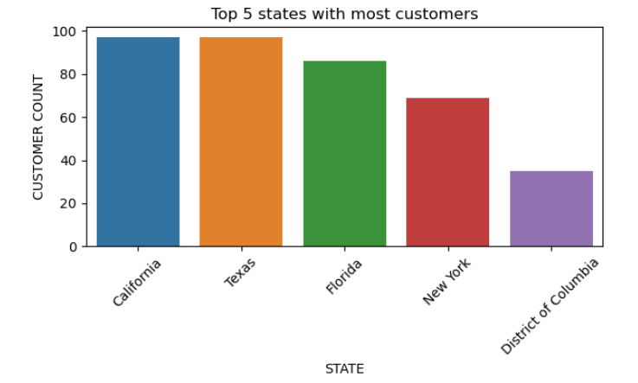

Observations / Findings

- California and Texas have the highest customer counts, each with 97 customers.
- Florida follows closely with 86 customer counts.
- New York with 69 customers and District of Columbia with 35 customers are other states in top 5 list with highest customer counts.
- Maine, Wyoming and Vermont states with 1 customer count come in the list of states at having lowest customer count.
- North Dakota, Mississippi are states in the bottom 5 list of customer counts with 2 customers in each state.
- States with lowest customer counts represent opportunities for target marketing.

Average Customer Ratings by Ǫuarter

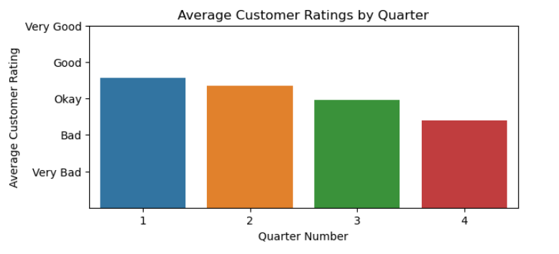
Observations / Findings
- Average customer rating is decreasing quarter over quarter, which indicates potential dissatisfaction in customers over time.
- Highest average rating between Okay and Good is in quarter 1.
- Lowest average rating can be seen between Bad and Okay in quarter 4.
- Majority of feedback is between Okay to Good.
- Need to focus on improving customer satisfaction over quarter and address any concern or issues if they are facing.

Trend of Customer Satisfaction

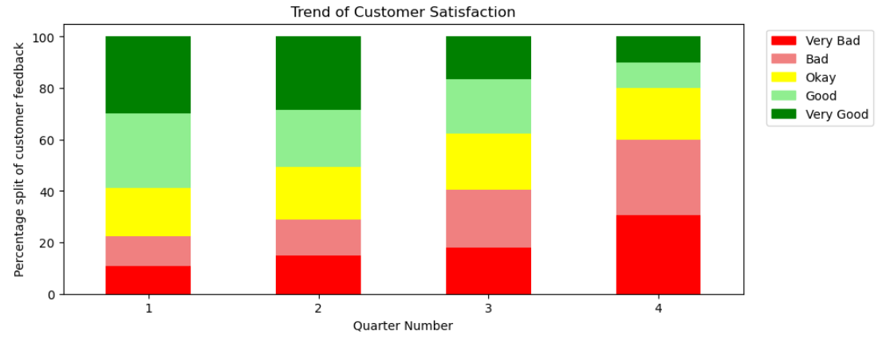

- Trend of customer satisfaction is decreasing quarter by quarter.
- Very Good and Good feedback percentage is decreasing quarter by quarter.
- Okay feedback percentage is stable for all quarters.
- Very Bad and Bad feedback percentage is increasing quarter by quarter.
- Quarter 1 has highest percentage of Good and Very Good feedback, whereas Quarter 4 has highest percentage of Bad and Very Bad feedback.
- Quarter 4 has significant shift towards negative customer feedback compared to previous quarters.
Observations / Findings

Top Vehicle makers preferred by customers

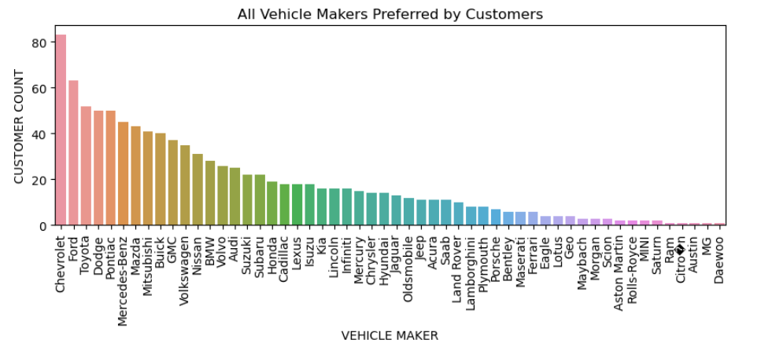

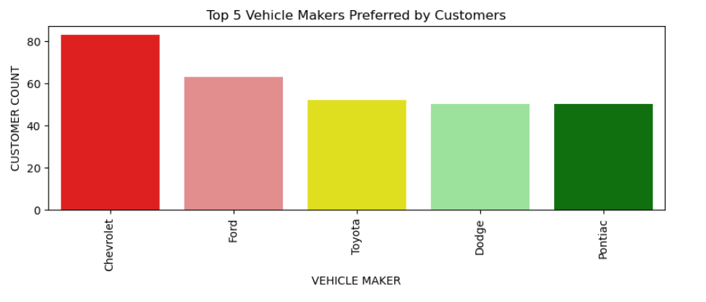

Observations / Findings
- Chevrolet is on top of the list of vehicle makers based on customer counts.
- Ford is 2nd on the top 5 vehicle makers list based on customer counts followed by Toyota, Dodge and Pontiac.
- Vehicle makers Daewoo, MG, Austin, Citro�n, Ram has lowest customer base.
- Luxury brands like Mercedes-Benz, BMW, Audi also have notable presence with good customer base which suggests customers are interested in these premium brands.

Most preferred vehicle makers in each state
Most Preferred Vehicle Makers in each state

State | Vehicle Makers
Alabama | Dodge
Alaska | Chevrolet
Arizona | Cadillac, Pontiac
Arkansas | Chevrolet, GMC, Mitsubishi, Pontiac, Suzuki, Volkswagen
California | Audi, Chevrolet, Dodge, Ford, Nissan
Colorado | Chevrolet
Connecticut | Chevrolet, Maserati, Mercury, Volvo
Delaware | Mitsubishi
District of Columbia | Chevrolet
Florida | Toyota
Georgia | Toyota
Hawaii | Cadillac, Ford, GMC, Nissan, Pontiac, Toyota
Idaho | Dodge
Illinois | Chevrolet, Ford, GMC
Indiana | Mazda
Iowa | Chevrolet, Chrysler, Dodge, Ford, Hyundai, Isuzu, Jeep, Mazda, Pontiac, Porsche, Subaru
Kansas | Buick, Dodge, Ford, GMC, Honda, Lexus, Maserati, Mazda, Mercedes-Benz, Nissan, Saab, Suzuki, Volkswagen
Kentucky | Acura, Audi, Mercedes-Benz, Mercury, Nissan, Pontiac, Ram, Volvo
Louisiana | BMW, Ford, Kia, Nissan, Pontiac
Maine | Mercedes-Benz
Maryland | Ford
Massachusetts | Chevrolet, Dodge
Michigan | Ford
Minnesota | GMC
Mississippi | Dodge, Toyota
Missouri | Chevrolet
Montana | Chevrolet, Dodge, Mitsubishi
Nebraska | Cadillac, Chevrolet, Mercedes-Benz, Nissan, Pontiac, Toyota, Volkswagen
Nevada | Pontiac
New Hampshire | Chrysler, Lexus, Lincoln
New Jersey | Hyundai, Mercedes-Benz
New Mexico | Dodge
New York | Pontiac, Toyota
North Carolina | Volvo
North Dakota | Ford, Hyundai
Ohio | Chevrolet
Oklahoma | Ferrari, Mazda, Toyota
Oregon | Toyota
Pennsylvania | Toyota
South Carolina | Acura, BMW, Buick, Dodge, Isuzu, Jaguar, Kia, Mazda, Mitsubishi
Tennessee | Mazda
Texas | Chevrolet
Utah | Buick, Chevrolet, Dodge, Isuzu, Lincoln, Maybach, Oldsmobile, Pontiac, Subaru, Volkswagen
Vermont | Mazda
Virginia | Ford
Washington | Chevrolet
West Virginia | Mercedes-Benz
Wisconsin | Acura, Cadillac, Chevrolet, Dodge, Honda, Mazda, Nissan, Pontiac
Wyoming | Buick

- There are many states which are having equal preferences to multiple vehicle makers, For example: State Arkansas, Arizona, California etc.
- We can see varying preferences of vehicles across different states, which can be due to various regional factors and market trends of the region.
- Toyota appears to be famous in Florida, Georgia, New York, Oregon, Pennsylvania etc.
- Chevrolet is quite preferred in most of the states.
- Luxury vehicles like Audi, Mercedez-Benz, BMW etc. popular in states like California, Kentucky, Louisiana, West Virginia, Maine etc.
Observations / Findings

Revenue Metrics

Trend of purchases by Ǫuarter

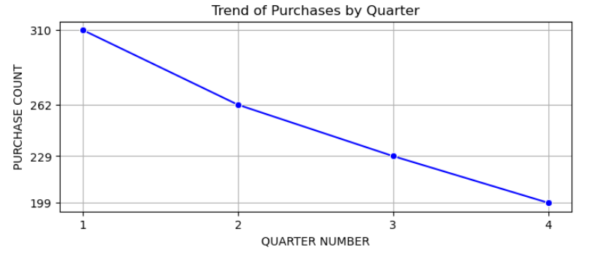
- Decreasing trend of purchases quarter by quarter.
- Quarter 1 has highest count of purchases 310.
- Next quarter has decreased purchase order always.
- Quarter 2 has 262 orders, quarter 3 has 229
- Quarter 4 has significant decrease in purchase count 199 compared to quarter 1.
Observations / Findings

Quarter on Quarter % change in Revenue

Quarter on Quarter % change in Revenue
Quarter Number | Revenue | Previous Revenue | QoQ Revenue Change | QoQ Revenue Change %
1 | 12.1 M
2 | 8.584 M | 12.1 M | -3.516 M | -40.97
3 | 5.956 M | 8.584 M | -2.628 M | -44.11
4 | 5.517 M | 5.956 M | -0.439 M | -7.98

Observations / Findings
- Simplified figures in millions have been shown in the above table for clearer picture on numbers.
- Quarter 1 has 12.1 million revenues
- Quarter 2 has 8.584 million revenues which has decrease of 3.516 million i.e. 40.97% decrease compared to quarter 1.
- Quarter 3 has 5.956 million revenues which has decrease of 2.628 million i.e. 44.11% decrease compared to quarter 2.
- Quarter 4 has just 5.517 million revenues which has decrease of 0.439 million i.e. 7.98% decrease compared to quarter 3.
- Revenue shows decrease trend quarter over quarter.

Trend of Revenue and Orders by Quarter

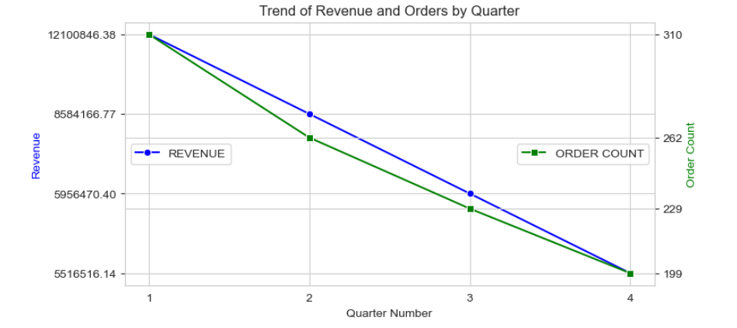

- Order count and Revenue both are strongly correlated.
- With decrease in order count, revenue is also decreasing quarter by quarter.
- Quarter 1 revenue is 12.1 million and order count is 310.
- Quarter 2 revenue decreased to 8.4 million with decrease in order count to 262.
- Quarter 3 revenue further decreased to 5.9 million with further decrease in order count to 229.
- Quarter 4 revenue again decreased to 5.5 million with decrease in order count to 199.
- Quarter 1 has highest order count and revenue among other quarters indicating strong start to the year.
- Consistent decrease in order count over quarter shows potential challenge affecting business performance.
Observations / Findings

Shipping Metrics

Average discount offered by Credit Card type

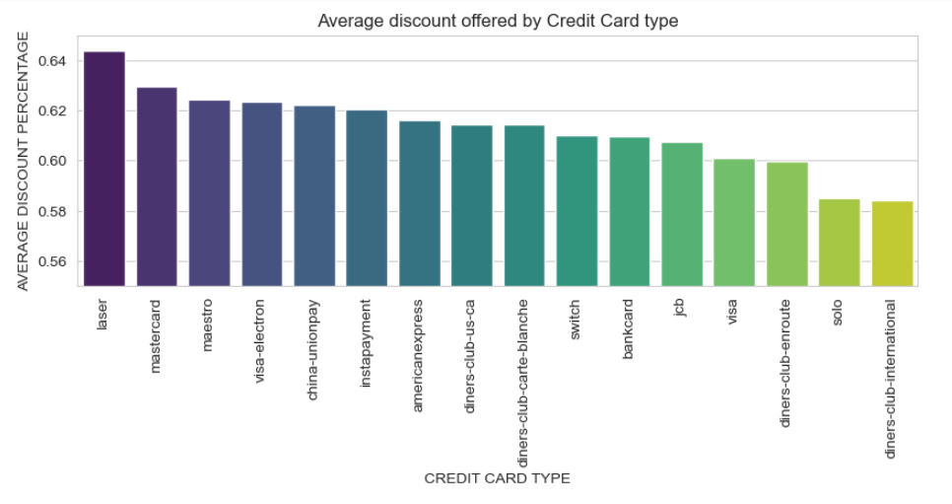

- Laser credit card is giving highest average discount of 0.64 followed by Mastercard 0.629, maestro and so on.
- Diners-club-international card is at the bottom of the list giving average discount of 0.584.
- Whereas diners-club-us-ca and diners-club-carte-blanche is giving an average discount of 0.614 making it in the mid of the list of all discount giver credit card.
- The average discounts for the remaining credit card types range from 0.584000 (diners-club-international) to 0.643846 (laser), showing a moderate variation in discount rates across different card types.
- Top 5 credit cards offering highest discount is laser, Mastercard, maestro, visa-electron and china-unionpay.
Observations / Findings

Time taken to ship orders by Quarter

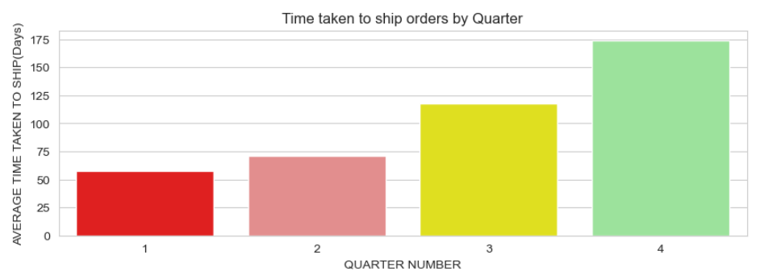

Observations / Findings
- Average time taken to ship kept on increasing quarter by quarter.
- Quarter 1 took less time approximately average 57 days to ship the order.
- Quarter 2 took more time around average 71 days to ship the order which is higher than quarter 1.
- Quarter 3 took even more time around average 117 days to ship the order which is significantly more time to ship indicating issues which should be looked.
- Quarter 4 took 174 days to ship the order.
- Increased shipping time from 57 days to 174 days may be one of the reasons of decreased order count and revenues. People could not wait for so many days to ship.

—

Insights and Recommendations
- Data indicates decrease in orders over the quarters. This trend needs to be investigated further to identify the underlying factor contributing to this.
- Factors influencing orders may be customer preferences, competitive market, market trends, shipping time.
- Data indicates customer feedback getting worst over the quarters. It means customers are getting dissatisfied over time. We need to understand the reason behind such feedback and take necessary action to overcome this.
- Quarter 1 is always good in terms of factors like order count, feedback, revenue, shipping time etc. we need to closely monitor to understand what is causing issues to these factors which is leading towards decline in orders over time.
- Data shows most preferred vehicle makers in each state which indicates regional preferences and market trends. Focusing on that, we should make market strategies, inventory management to align with customer needs.
- Optimizing discount strategies based on credit card preference may attract more customer and improve sales performance.
- Enhance the after-sales service to improve customer satisfaction and loyalty.
- Implement targeted marketing campaigns, promotions, and discounts.
- Do the comprehensive analysis every quarter using quarterly business report and take necessary action to improve the performance of sales.

